Guidelines for Supervising Computer

Assisted Personal Interview (CAPI)

Demographic and Health Survey 2015-2016

MCj04281370000[1]j0205462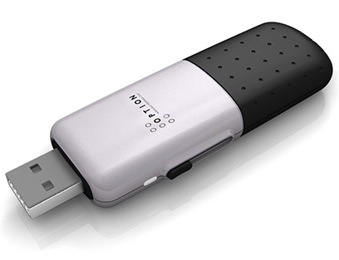

**I2**

**I1**

**Backup**

**Central Office**

**Internet - GPRS**

**Upgrades**

**Send/Receive Data**

ICF International has developed a comprehensive automated field supervisor’s system for the Demographic and Health Survey. Knowing this control system is a critical component of being an effective supervisor. There are a series of supervisor specific tasks that were undertaken during a paper interview but are now integrated parts of the CAPI system. You should understand three layers of functions across the whole system, in order to organize and supervise the fieldwork successfully. These layers include:

1. Controlling the conduct of interviews among the team, through Bluetooth
2. Completing your own tasks
3. Communicating with the central office, through IFSS

The supervisor’s system looks similar to the interviewer’s application. Below is the welcome screen for the system.

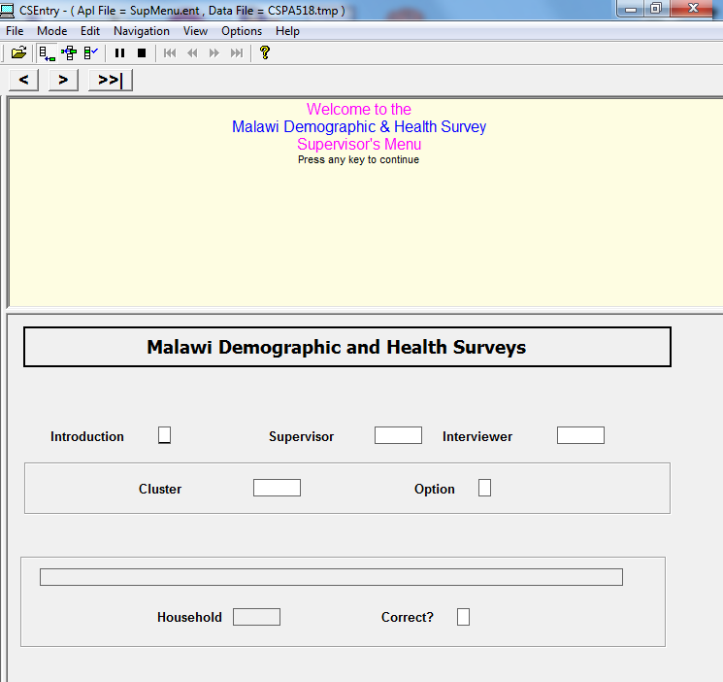

When you move forward on this landing page of the application, you will see the following:

[Introduction]: Press any key to continue and the application will automatically go to the next field.

[Supervisor]: Every supervisor has his/her own code. Select your code every time you work with the application. Note the names of all the supervisors are displayed. If you have forgotten your ID number, simply browse through the names.

[Interviewer]: Some actions in the supervisor menu required you to select a specific interviewer. When selecting an interviewer, verify his/her code with the name provided in the list of the pop up.

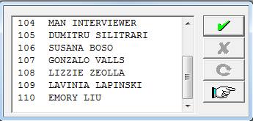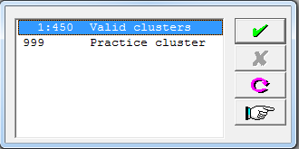

[Cluster]: The entire sample is divided in clusters. Each cluster has a certain number of households. Every time you change your location, you will start a new cluster. It is very important to select the correct cluster before starting the work. Double check the cluster number with the instructions given by the central office. Because there are a large number of clusters, the application provides a range. You will have to key in the correct number using the keyboard.

Note: Be careful in selecting the cluster. The default value is 1. Do not just click the choice with the stylus/ figure. You will have to key in the correct cluster number. Otherwise you will be automatically selecting the default value.

On the top of the screen there are three buttons for browsing through the questionnaire:

C:\Users\Dumitru Silitrari\Desktop\ScreenShot033a.bmp for going back, C:\Users\Dumitru Silitrari\Desktop\ScreenShot033b.bmp for going forward, C:\Users\Dumitru Silitrari\Desktop\ScreenShot033c.bmp if you want to skip and go to the last completed variable.

Note: The instructions are written in blue and purple. Blue is used for general information on specific option and purple is used to give practical instructions on how to select the proper options.

After you press any key at the Option box, you will see the supervisor’s main menu as shown below.

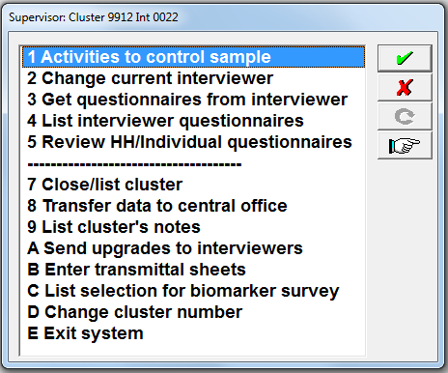

The following table gives an overview of the control system which you will be operating from the main menu. Each level represents a series of options that are displayed on the screen. Familiarize yourself with the table.

Table 1: Menu system for supervisor

|  |  |  |
| --- | --- | --- |
| **Level 1** | **Level 2** | **Level 3** |
| 1 Activities to control sample | 1.1 Manipulate Control file | *1.1.1 Modify Total # of households* |
| *1.1.2 Delete Household* |
| *1.1.3 View Households Received* |
| *1.1.4 Return to the Main Menu* |
| 1.2 Assign households for cluster | *1.2.1 See table of assignments* |
| *1.2.2 Assign Interviewers* |
| *1.2.3 Change household addresses* |
| *1.2.4 Change household head names* |
| *1.2.5 Add a household* |
| *1.2.6 Change selection for men survey* |
| *1.2.7 Return to the Main Menu* |
| *1.3 Send household assignment to interviewers* |  |
| *1.4 Return to the Main Menu* |  |
| 2 Change current interviewer |  |  |
| 3 Get questionnaires from interviewer |  |  |
| 4 List interviewer questionnaires |  |  |
| 5 Review HH/Individual questionnaires |  |  |
| 7 Close/ list cluster |  |  |
| 8 Transfer data to central office |  |  |
| 9 List cluster’s notes | *9.1 Households* |  |
|  | *9.2 Individuals* |  |
| 10 Send upgrades to interviewers |  |  |
| 11 Enter transmittal sheet | *11.1 Add bar code* |  |
|  | *11.2 Remove bar code* |  |
| 12 List selection biomarker survey |  |  |
| 13 Change cluster number |  |  |
| 14 Exit system |  |  |

**In the following sections, we will discuss options from the main menu and their sub-menu options one by one.**

[**Main Menu] -> [1 Activities to control sample]**

This function allows you to assign households and manage workload (via Bluetooth). When you select this option, a sub-menu will appear. This provides the lowest level of choices for controlling the sample.

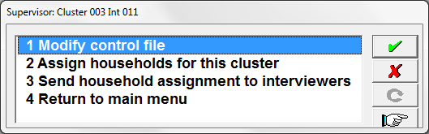

[**Main Menu] -> [1 Activities to control sample] -> [1.1 Modify control file]**

You will be directed to a cluster control window.

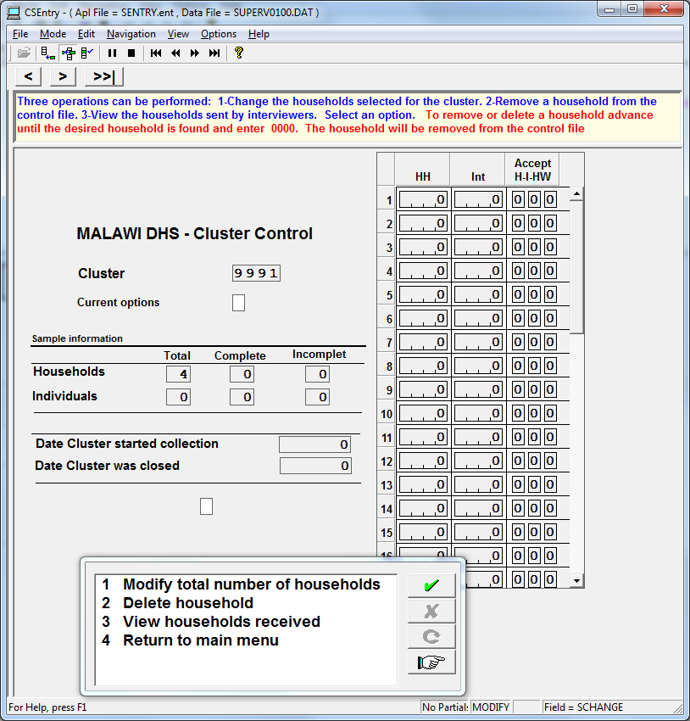

This window shows several pieces of information related to this cluster.

**Cluster** code – code of cluster selected.

**Sample information** displays the total number of questionnaires expected to be interviewed for the cluster. This should equal the sum of complete and incomplete questionnaires.The information is presented both – for household and individual questionnaires. Note that the individual questionnaires are only displayed after completing the household questionnaire.

**Date cluster started** and **Date cluster was closed –** notice that date will appear automatically depending on the date when the first questionnaire started, and after data collection in cluster is over.

Please note that the date format in screen is yy-mm-dd.

On the right side of the screen you will see a roster displaying information on each household. Every household that needs to be visited will be displayed in column [**HH]** – you will see its code (that corresponds to its ordinal number in the listing document. Column **Int** presents the code of the interviewer to whom this household was assigned. A Column **Accept** displays the number of accepted questionnaires split by type **H-**household**, I**-Individual and **HW -** biomarker**.** Here you will see the number of questionnaires that were accepted by the system.

At the current option box, you will choose options from another sub menu.

1. Modify total number of households
2. Delete household
3. View households received
4. Return to main menu

[**Main Menu] -> [1 Activities to control sample] -> [1.1 Modify control file] ->** **[1.1.1 Modify total number of households**]

**Note Instructions:**

The number of households selected for cluster X was assigned based on sample design. However with this option you can change it. Enter the modified value.

**Note changes to the screen:**

Current options: will display 1, since you selected option [**1 Modify total number of households**].

Cursor will automatically go to box [**Total**] in the row [**Households**] allowing to correct the initial number of households.

**Note result:**

1. Write the correct number of households.
2. Press **[Enter].**
3. After you write the new number, apop up window will appear askingif the new number is correct. After selecting [**Yes]** the new total number will be saved.
4. Cluster control interface will close and you will return to the main menu.

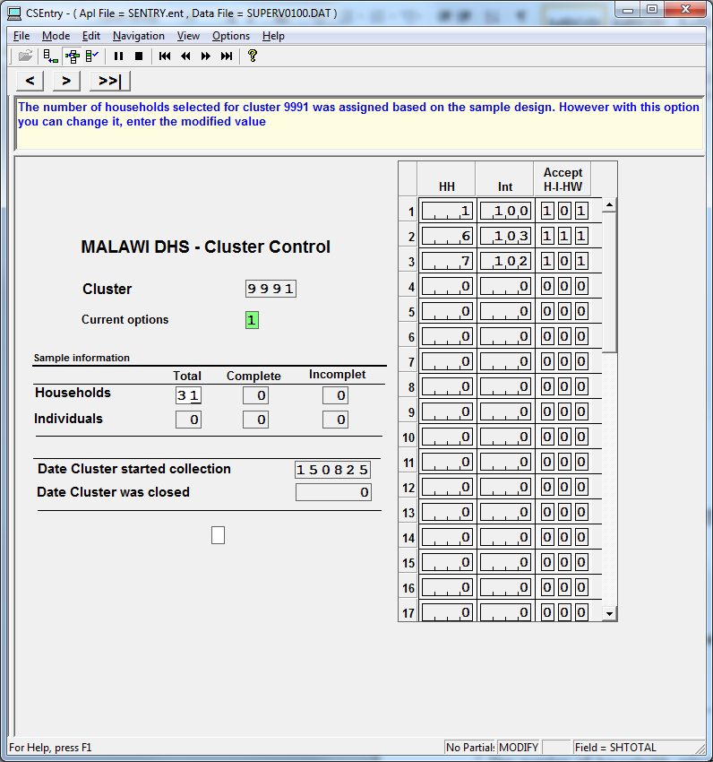

[**Main Menu] -> [1 Activities to control sample] -> [1.1 Modify control file] ->** **[1.1.2 Delete households**]

**Note changes to the screen**:

[**Currrent options**] will show number 2, since you selected option

[**2 Delete households**]

Cursor will automatically go to box [**Households**] in the roster on the right, allowing to write 0000 in place of the ordinal number of the household you want to delete in the column **[HH]**.

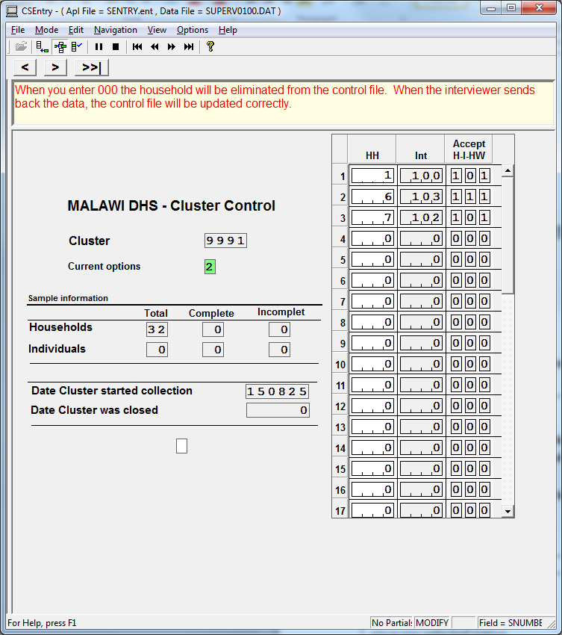

**Note result**:

After writing 0000, the line with the household will disappear, and the next household will replace the eliminated one.

**Note Instructions**:

**When you enter 0000 the household will be eliminated from the control file. When the interviewer sends back the data, the control file will be updated correctly.**

[**Main Menu] -> [1 Activities to control sample] -> [1.1 Modify control file] ->** **[1.1.3 View households received**]

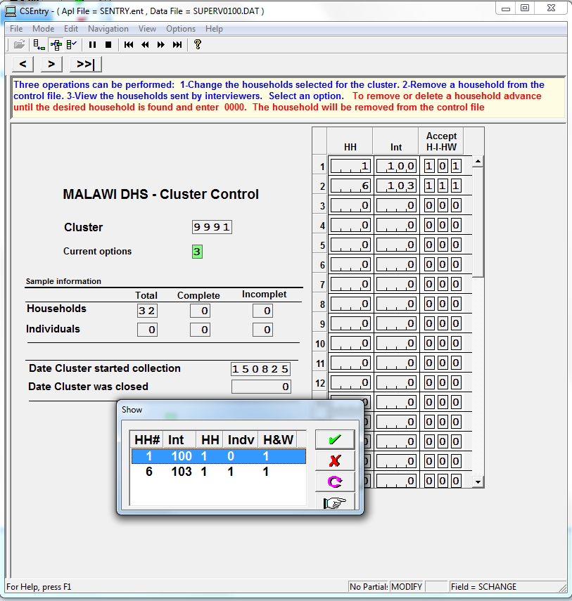

**Note options**:

A pop up box is displayed entitled SHOW and this displays the current status of the cluster. Note the contents have the same column structure as the right hand roster with: number of households interviewed, and statistics on types of questionnaires completed and the assigned interviewer.

Note that the box has the column headers:

HH# Household number

Int Interviewer code

HH Household accepted

Indv Interviewed women and men accepted

H & W biomarker section accepted

[**Main Menu] -> [1 Activities to control sample] -> [1.2 Assign households for cluster]**

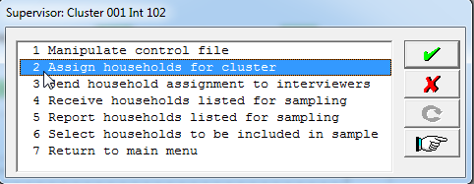

**Note changes to the screen:**

This is the households listing interface. On the top side of the screen you can find general information about cluster: [**Cluster number]** and number of [**Households selected in cluster].**

**[Changes to be made]:** this box containsthe code of the option that you select in the pop up box.

**[HH Number]:** Note the household numbering sequence is the same ordinal ID provided in the cluster control file in the table on the right.

**[Households Address and Name of Household Head]:** Please note that the screen now displays the actual addresses of the selected households; these addresses will be used by interviewers to locate the households. Make sure the addresses are written correctly and are easy to reference.

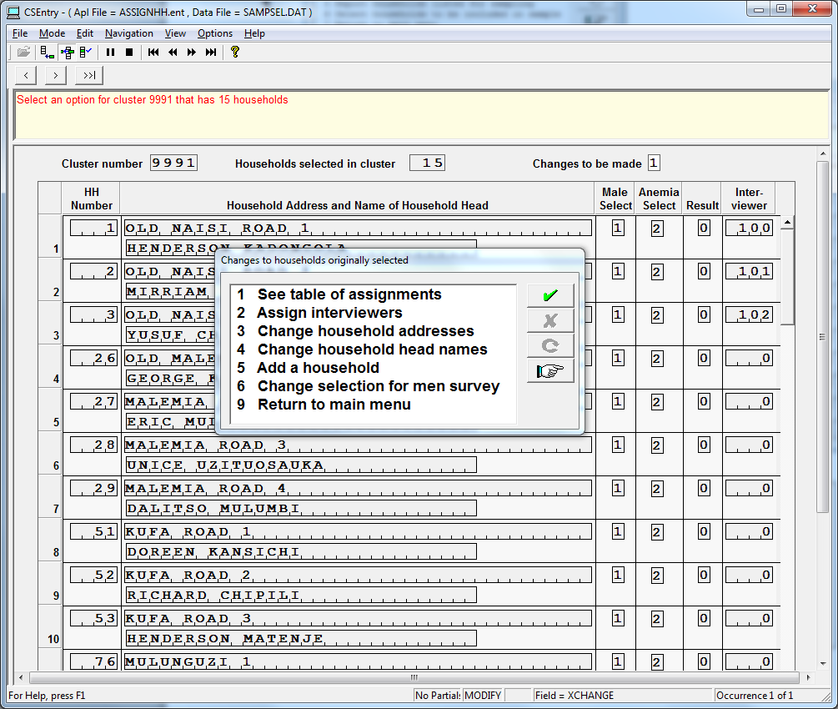

**Note the options**:

1. See table of assignments
2. Assign Interviewers
3. Change household addresses
4. Change household head names
5. Add a household
6. Return to Main Menu

[**Main Menu] -> [1 Activities to control sample] -> [1.2 Assign households for cluster] -> [1.2.1 See table of assignments]**

A pop box entitled SHOW will present the assignments of households and their assigned interviewer.

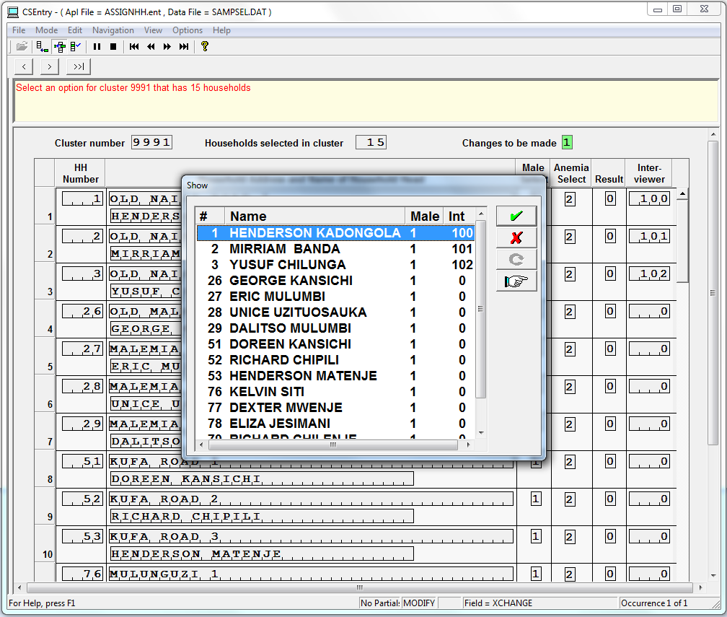

[**Main Menu] -> [1 Activities to control sample] -> [1.2 Assign households for cluster] -> [1.2.2 Assign Interviewers]**

This panel provides the most important feature which is assigning households to interviewers. This needs to be done at the beginning of data collection in the cluster.

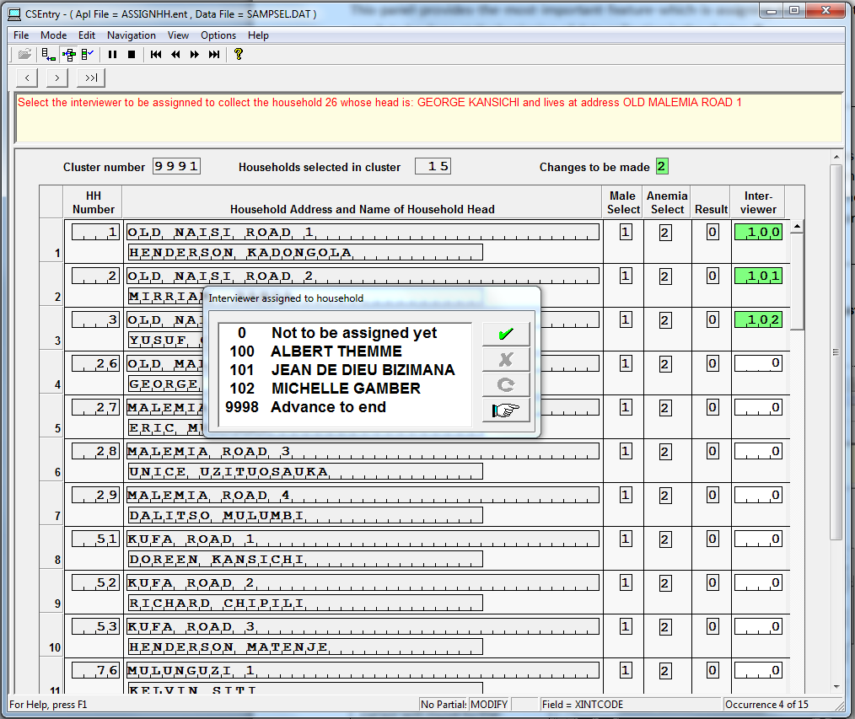

**Note results**:

A pop up box named INTERVIEWER ASSIGNED TO HOUSEHOLD shows the codes of the interviewers and their names. You will see that cursor now is in the [**Interviewer**] column. Assigning households automatically starts with the first household in the list. As soon as you choose the interviewer whom you want to assign the first household on the list, press the **[green check],** the cursor will automatically go to the next household and allow you to assign it to an interviewer.

[**Main Menu] -> [1 Activities to control sample] -> [1.2 Assign households for cluster] -> [1.2.3 Change household address]**

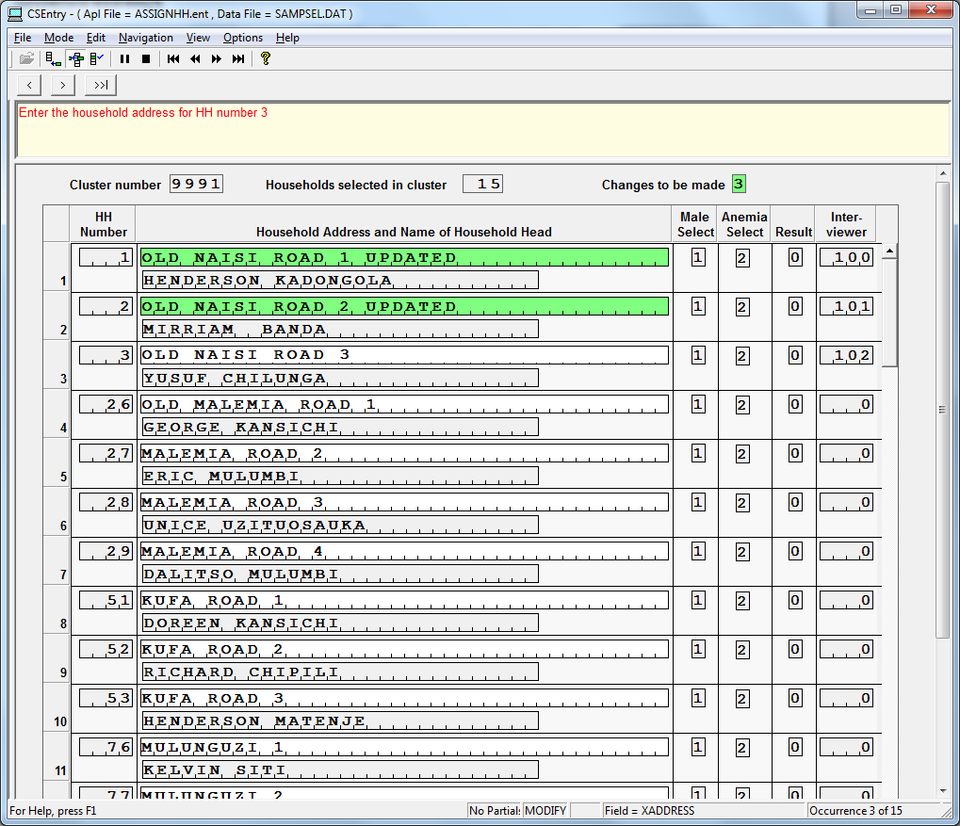

**Note changes to the screen**:

Note the upper right [Changes to be made] now displays the menu selection ‘3’, like all other options discussed before.

**Note results:**

The cursor will automatically go to address line, allowing to re-write the existing address. Press [**Enter**]. The line will become green and cursor will move to the second household, and so on until all household addresses are updated or checked.

[**Main Menu] -> [1 Activities to control sample] -> [1.2 Assign households for cluster] -> [1.2.4 Change household head names]**

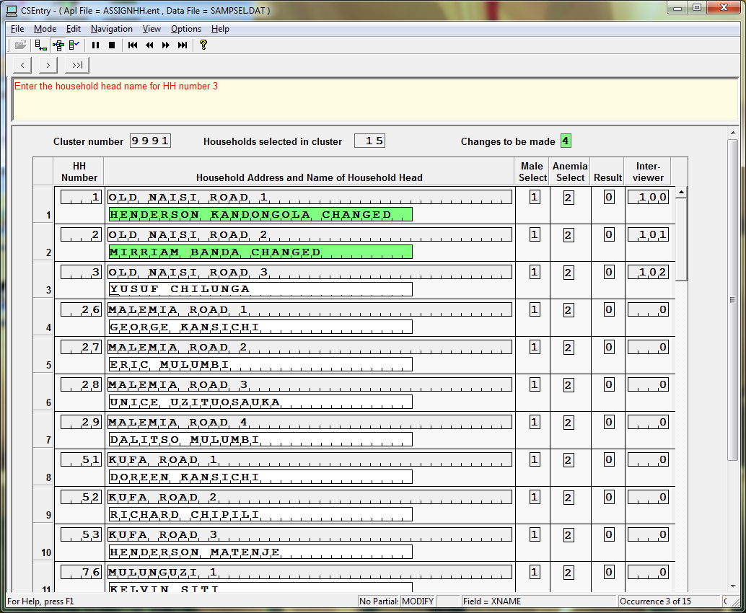

**Note changes to the screen**:

Note the upper right [Changes to be made] now displays the menu selection ‘4’.

**Note results**:

1. The cursor will automatically go to [**Name of household head**] line, allowing correcting the existing name with the new one.
2. Choose the line where you need to make the corrections.
3. Make the necessary corrections.
4. Press [**Enter**].

The line will become green and cursor will move to the next household, and so on until all household names are checked.

[**Main Menu] -> [1 Activities to control sample] -> [1.2 Assign households for cluster] -> [1.2.5 Add household]**

This option is used to deal with situations where a single household was listed, but on visiting that household, the interviewer identifies one or more households in that dwelling. In this case you may use option 5 “Add household” to create one or more additional households, in order to enable the interviewer to interview all the households at the dwelling concerned.

**Note results**:

1. The cursor will automatically go to the line after the last existing household.
2. What you need to do is
3. At [**Address Line**] line**->** add the new address**->** Press [**Enter**]
4. At [**Name of household head**] line**->** add the new address. **->** Press [**Enter**]
5. At [Male Select], select whether the household is eligible for the male questionnaire. Use the selection applied to the original household
6. [Anemia Select] and [Result] are entered automatically
7. Assign Interviewer]**->** Press [**Enter**]

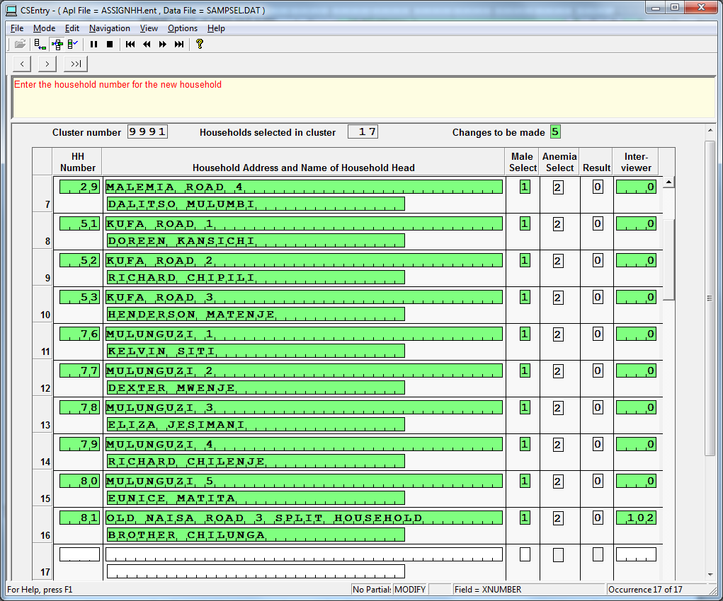

The tablet will then save the information for the new household. Remember to send the new assignment to the interviewer via Bluetooth after adding the new household.

[**Main Menu] -> [1 Activities to control sample] -> [1.2 Assign households for cluster] -> [1.2.6 Change selection for male survey]**

This option is not permitted.

[**Main Menu] -> [1 Activities to control sample] -> [1.3 Send household assignment to interviewers]**

**Send household assignments to interviewers** – After assigning households to interviewers, use this option to send to their tablets the new assignments. Make sure to connect your Bluetooth, and the interviewers’ tablets Bluetooth. Sending assignments is an action requiring that both interviewers and supervisor tablets be turned on.

**Supervisor’s actions**:

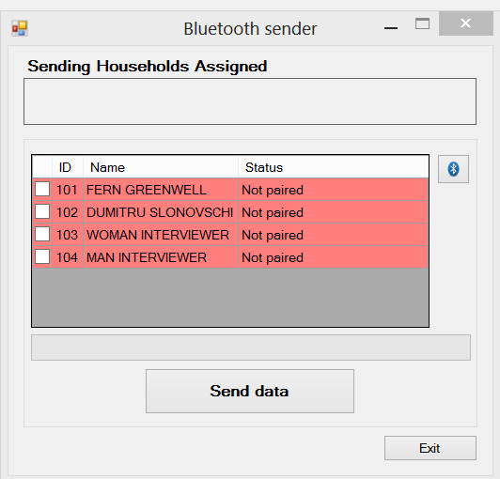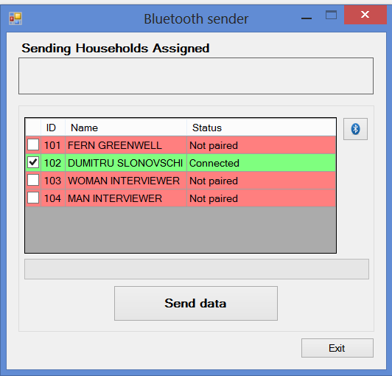

1. A Bluetooth sender window will appear, showing the process of sending. On this screen you will see your interviewers and connection status. If sending failed, then each row will be coloured with red showing status “Not paired”.
2. If at least one connection is established, then the row will be coloured with green and show status [**Paired**]. If several devices are paired, put the check in the checkbox next to the necessary one.
3. Press the button [**Send data**].

Make sure, that every interviewer from your team received the assignment, if the connection fails multiple times, check the Bluetooth status on interviewer tablets, also the actions they are taking with their application. Check the status of transmission, and observe if every operator received the files.

When the transfer is completed the system will return to the main menu.

**[Main menu] -> [2 Change current interviewer]**

This function allows you change the interviewer’s code. You will need to confirm or adjust the cluster number that you and the interviewers are currently working on.

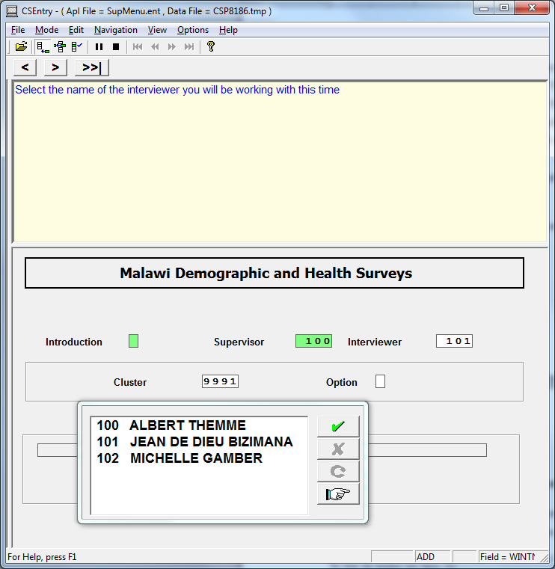

**[Main menu] -> [3 Get questionnaires from interviewer]**

The function allows you to receive both the completed and incomplete interview data from the interviewers. Before starting transferring data make sure that Bluetooth is on. Only after this option, you will be able to perform the following few options.

On the interviewer’s tablet ask the interviewer to use option “A” to access the “Data Exchange/Other utilities” option and then option 1 “Transfer cluster data to supervisor” to send the questionnaires collected by that interviewer from the interviewer’s tablet to your tablet. Remember that both steps are also needed when you interviewed a household or respondent on your supervisor tablet. In this case the files are copied from \DATA to \TEMP and from \TEMP to \RECEIVE.

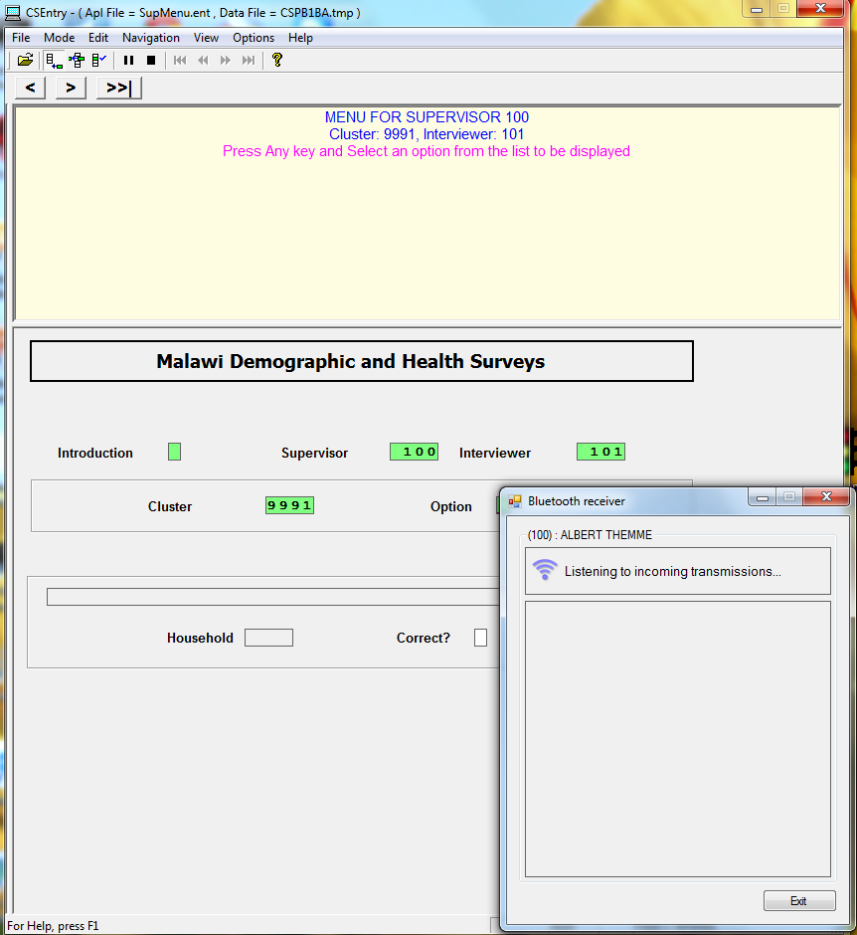

A mall pop up box entitled BLEUTOOTH RECEIVER shows supervisor’s code and name and a status:

LISTENING TO INCOMING TRANSMISSION…

**Note instructions:**

MENU FOR SUPERVISOR 11

Cluster: 3, Interviewer: 12

Press any key and Select an option from list to be displayed

Once the program has reviewed all of the questionnaires, a cluster progress report of questionnaires will be displayed. This cluster progress report will include not only the questionnaires collected by the particular interviewer, but also the questionnaires collected by the other interviewer’s in the team and that have already been transferred to the supervisor’s tablet.

**[Main menu] -> [4 List Interviewer Questionnaires]**

The option gives you the opportunity to see a summary of the interview progress for the current cluster. It will display a summary similar to the one generated through [Main menu] -> [7 Close/list cluster], but without checking the consistency between biomarker questionnaire and transmittal sheet.

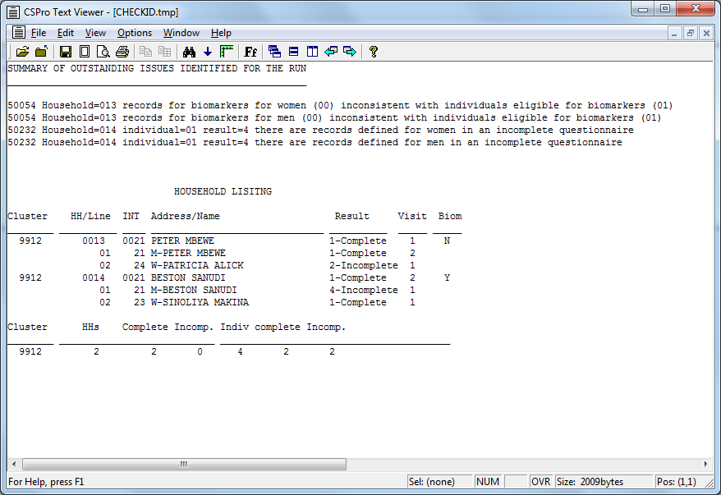

This listing pertains to the households 13 and 14 completed by Interviewer 21. Error messages 50054 indicate that the biomarkers for household 13 have not been entered. This is also marked by the “N” under “Biom”. Error messages 50232 indicate that there is something wrong with household 14 as well.

Using the next option [5 Review Household Questionnaires] and selecting line number 1 in household 14, the following message is displayed, indicating that this case was partially saved. The interviewer can use the”Advance to end”  button to move through the questionnaire and review any error messages.

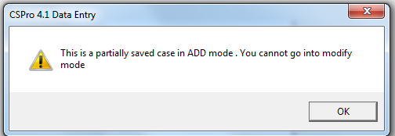

**[Main menu] -> [5 Review Household Questionnaires]**

This function allows supervisors to see what data have been collected by the team. It will give you a list of interviewed households, as shown below.

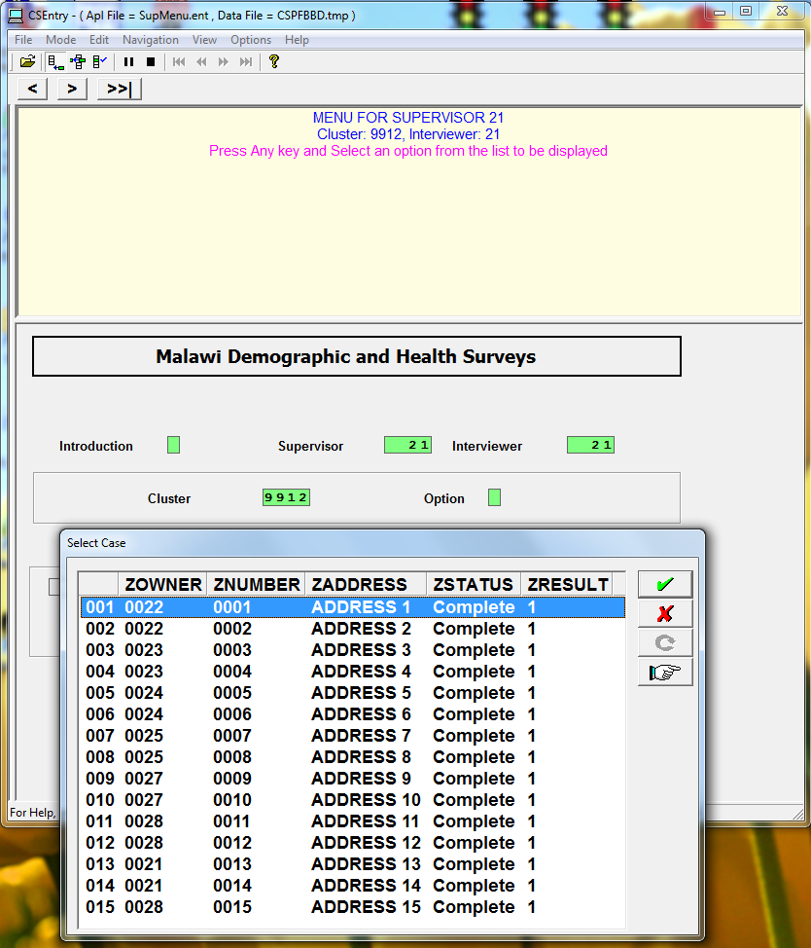

After a household is picked up, you will be asked to confirm the basic information of the household before proceeding. Click on ‘Yes’ if all is correct.

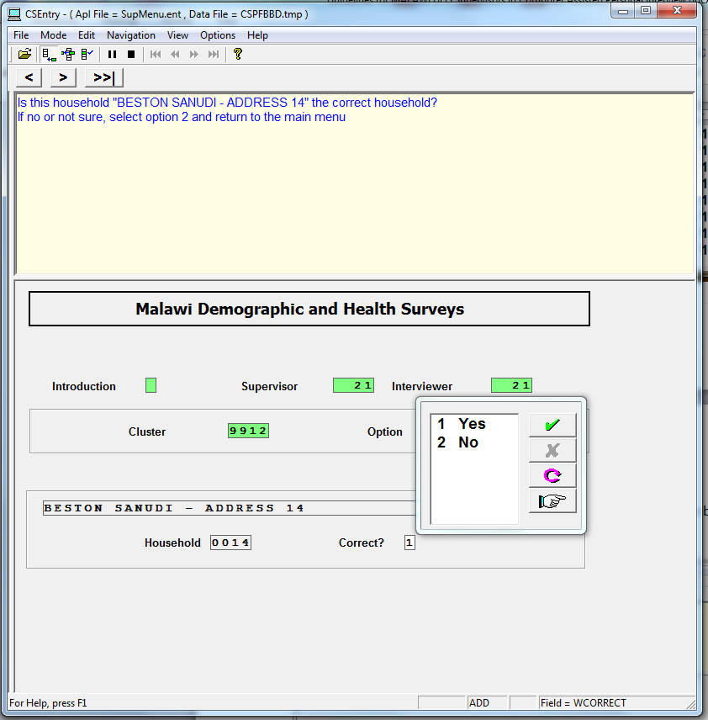

After you specify either the household questionnaire (including the biomarker questionnaire) or the individual’s questionnaire, you will be directed to the cover page of the questionnaire for starting your review.

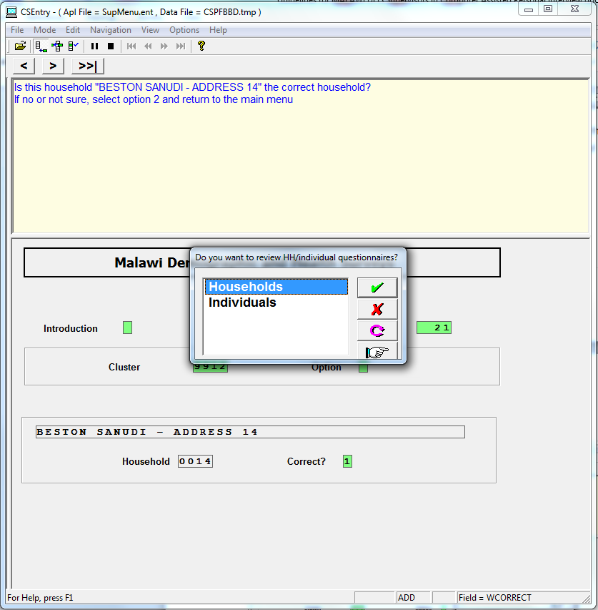

**[Main menu] -> [7 Close/list cluster]**

When all work is completed in the cluster, the supervisor must run this menu option to “close” the cluster. CC_DHS software will check all of the questionnaires in the cluster for all interviewers are present on the supervisor tablet. In addition to checking the questionnaires, it also checks that the bar codes entered by you in the transmittal sheet match the bar codes entered from the biomarker forms by the interviewers in the household questionnaires. Supervisors need to use the report generated ( as shown below) to instruct interviewers how to correct data in this cluster. It doesn’t check every single digit in the data file, but focus on mostly the structural information of the cluster.

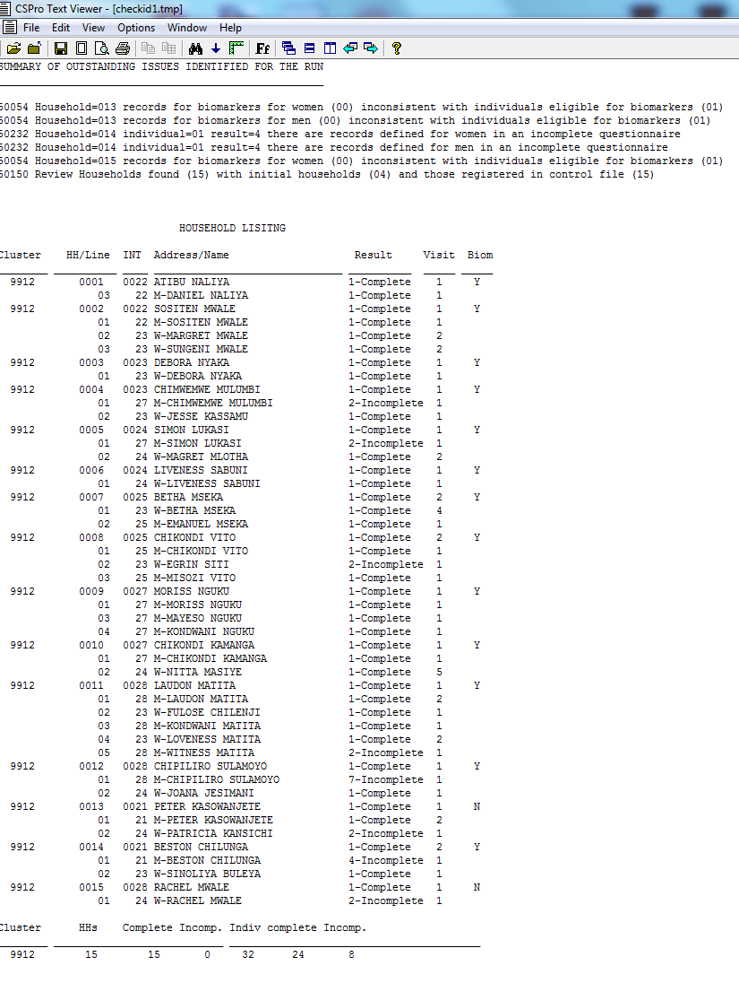

Unless the cluster’s data pass all the system checks under this function, you will receive the error message as shown below.

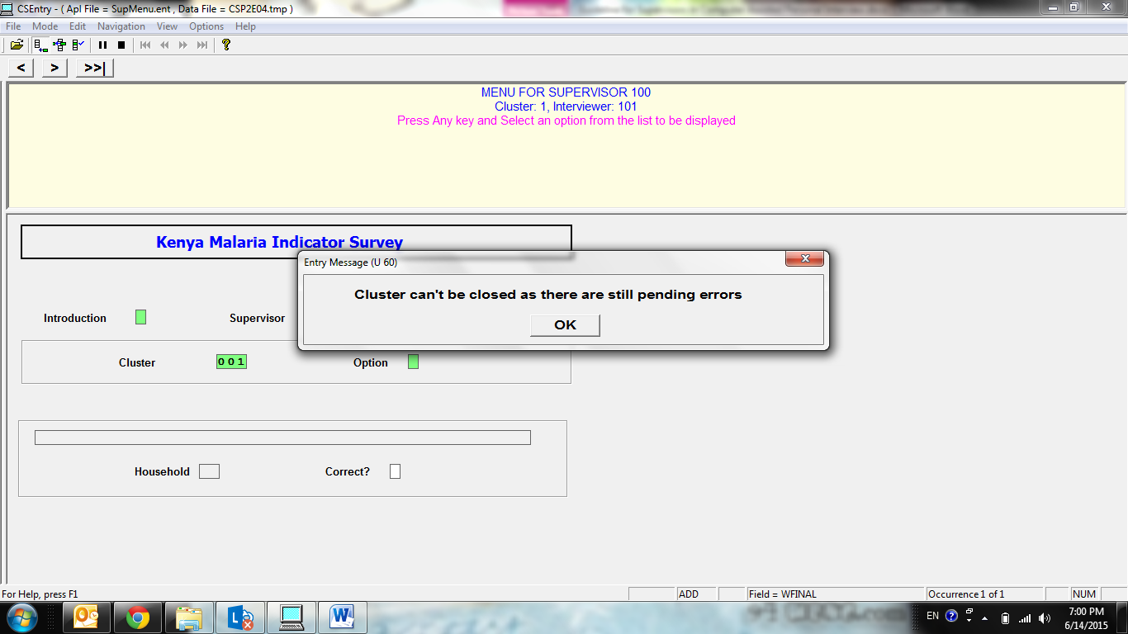

“Closing” the cluster is the last step for the team and supervisor before leaving the cluster.

The steps for the close are as follows:

1. All interviewers run option 9 “List questionnaires in cluster” and check that they have completed all questionnaires. No “partial cases”, or cases “not visited” should remain, and the number of biomarkers listed under “H/W” should match (i.e., the number of women, men and children eligible for biomarkers in this household, should match the number of biomarker measurement taken).
2. All interviewers send their data to the supervisor
3. The supervisor ensures all biomarker questionnaires are completed and entered
4. The supervisor ensures that all bar codes from the transmittal sheets have been entered on the supervisor electronic transmittal sheet using option 11 “Enter transmittal sheet” on the supervisor menu.
5. The supervisor then uses the option 7 “close/list cluster”

If there are no outstanding items or errors, the system will display a message with the text “Cluster successfully closed”. If there are remaining issues to be resolved, the system will indicate that the cluster cannot be closed until the issues are resolved.

Checks that are made during the close:

1. All selected household must be visited with **EITHER:**

* A complete interview **OR**
* An interview recorded with an incomplete result code e.g. “Postponed”, “Refused”, “Dwelling not found” etc.

1. All eligible women and men must be visited with **EITHER:**
   * A complete interview **OR**
   * An interview recorded with an incomplete result code e.g. “Postponed”, “Refused”, and “Incapacitated” etc.
2. No partially saved data (all interviews finished or marked result code <> 1)
3. All biomarker measurements and tests must be completed, including cases where respondents refused, or filled out with “Not Present” codes.
4. All transmittal sheet barcodes scanned
5. Each barcode found in the biomarker questionnaire must have a corresponding entry in the transmittal sheet.

**Resolving outstanding issues to close the cluster.**

The first step in resolving any outstanding issues prior to closing the cluster is read the status report carefully. For each error message or missing item, note the following:

1. Household number
2. Line number (if the issue affects an individual questionnaire)
3. Code and name of the interviewer responsible for the household, individual or biomarker questionnaire.
4. Details of the message

The following procedures should be followed to resolve outstanding issues.

**Questionnaires not completed**

1. Instruct the interviewer to return to the household and complete the interview
2. If the interview cannot be completed, enter the cover sheet on the tablet and record the reason why the interview cannot be completed, then transfer interviews to the supervisor.

**Questionnaires that are partially saved, or messages indicating that sections are missing or are in the wrong questionnaire.**

1. Check the interview on the interviewers machine and use the “>>|” “Go to End” button to try to go to the end of the interview and save the data.
2. If there are questions remaining to be completed, instruct the interviewer to return to the household to complete it.
3. Resend the interviewers data back to the supervisor and re-run the close.

**Bar code inconsistencies**

If the bar code is present in questionnaire and not in the transmittal sheet, write the bar code manually in transmittal sheet. Then enter the code in the electronic transmission sheet on the supervisor tablet.

If the bar code is present in the transmittal sheet, but not in the biomarkers questionnaires, check the biomarkers questionnaire to ensure the bar code was not skipped due to a keying error. If the bar code is present, correct the biomarkers questionnaire. If it is not present, bring the problem to the attention of the interviewer responsible for the biomarkers questionnaire. **The interviewer should be reminded that omitting the barcode from the biomarker questionnaire is a serious error that should not be repeated.** Note that this particular error will not prevent the cluster from being closed, since there is no way to resolve it at this point.

**Note that the cluster cannot be closed if there are duplicate cases in the data file.**

Once all of the data for the cluster have been entered and all errors that the program displayed have been corrected, the cluster is considered complete, and can be sent to the NSO central office via the internet. **[Main menu] -> [8 Transfer Data to Central Office]**

This function is to let supervisors communicate with the central office through IFSS. A timely operation on this will help backing up the interview data in the cloud / central office. It will also allow central office to process other tasks in time, such as secondary editing, producing field check tables, evaluating the current fieldwork, etc.

When clicking on this function, you will first be reminded of connecting to Internet. This is a reminder, not an error message. Simply click on ‘OK’ to proceed.

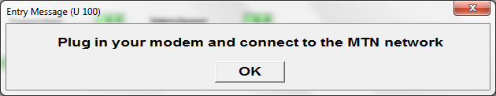

Then you will be directed to the IFSS login window. If you have been set up for automatic login, you will not need to repeat entering your user name and password. After a successful login, the data in your tablet will be transferred to IFSS, and later on downloaded to the central office.

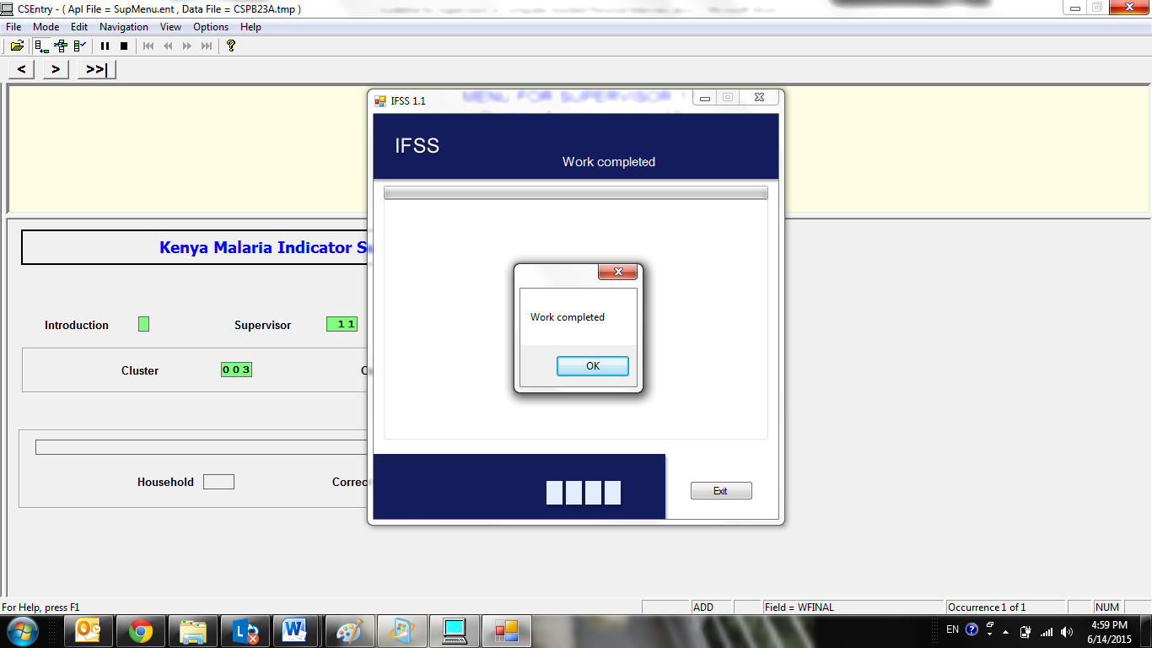

A confirmation message will be popped up when the transfer is finished. Simply click on ‘OK’ to return to the main menu.

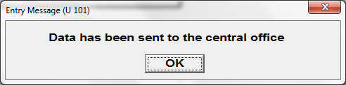

**[Main menu] -> [9 List cluster’s notes]**

You can use this option to review the notes that interviewers have recorded by the end of each questionnaire. The notes are sorted by questionnaire type.

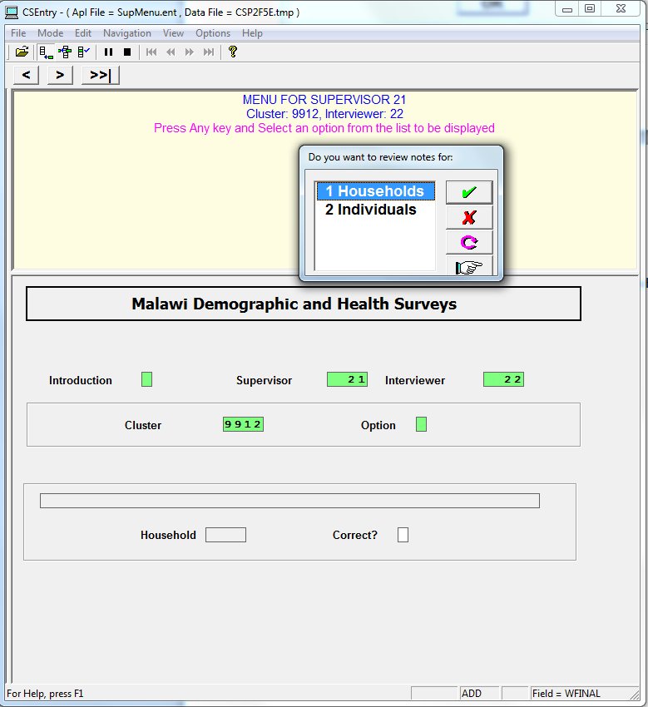

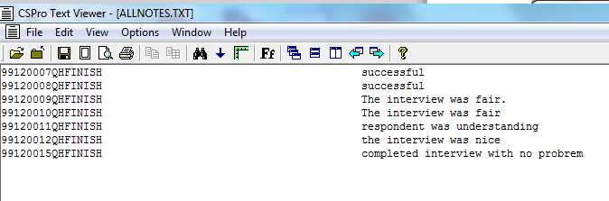

**[Main menu] -> [10 Send upgrades to interviewers]**

From time to time, upgrades may be downloaded to your machine by the IFSS tool. If these upgrades need to be installed on the interviewer tablets in your team, the system will display a message alerting you.

Upgrades are transferred to the interviewer tablet using Bluetooth transfer. The procedures for transfer are essentially the same as for transferring the household listing to interviewers. Upgrades can be transferred to multiple interviewers at the same time.

To transfer and install upgrades on the interviewer tablet after you have been alerted to a download by IFSS use option 10 “Send upgrades to interviewers”. The interviewers must use option “A” “Data exchange/other utilities” and then select “5” “Receive system updates from supervisor” to put their machines in receive mode prior to the supervisor sending the upgrade.

Once the upgrade is transferred the system will automatically install it on the tablet of the interviewers. After installation a message will be displayed indicating that the tablet menu will shut down to allow the upgrade to be applied. Click “OK” and the system will exit the menu. Restart the interviewer menu to complete the upgrade process.

Upgrades for the supervisor machine are installed automatically and do not require any further action on the part of the supervisor.

If there are no new upgrades to be transferred, an error message will appear as below.

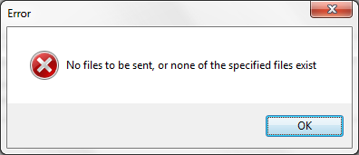

**[Main menu] -> [11 Enter transmittal sheet]**

A barcode is a critical identification for a HIV testing sample. It consists of five alpha and numeric symbols in formulated way. They are printed and readable with a barcode reader. There are three copies of each code. One will be pasted on the HIV DBA sample; another one goes in the paper-based biomarker questionnaire and the third will go on the transmittal sheet. You as a supervisor will need to scan/enter the barcode pasted on the transmittal sheet into the system through this particular menu option.

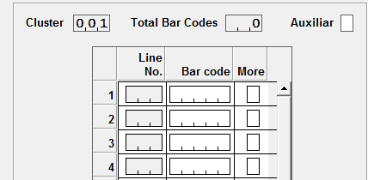

**Note changes to the screen:**

The screen will now display a new control roster with the following information:

The bar code is a five-digit alpha-number that begins with a letter followed by a number.

**Note options:**

1 Add bar code: allows addition of a barcode.

2 Remove bar code: allow deletion of a barcode

9 Cancel: return to the main menu.

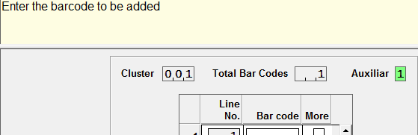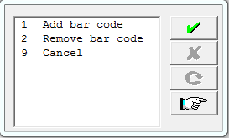

1. In the ‘adding’ mode, the cursor moves into the bar code position and awaits entry of the bar code pasted on the transmittal sheet. If there is no more barcode to enter, click on ‘No’ in the pop-up box at the end of the current line of entry.

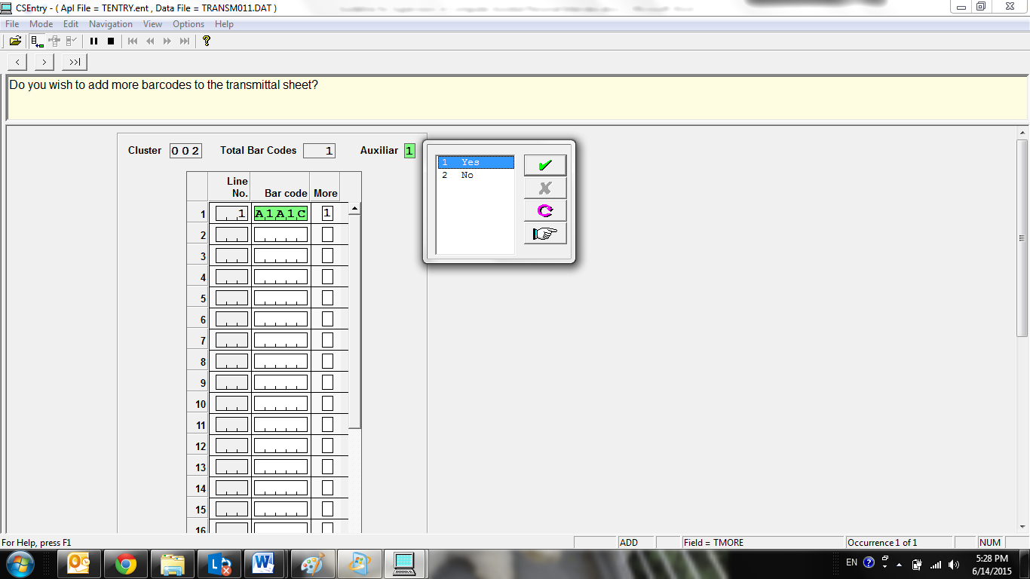

1. In the ‘removing’ mode, the cursor will move to the ‘line No.’ column. The column will show a color of white. If you want to delete a particular barcode, make its line number to be 0, then press ‘Enter’. This action will delete the barcode, close the window and return to the main menu. The example below shows a deletion of barcode ‘A1A1C’.

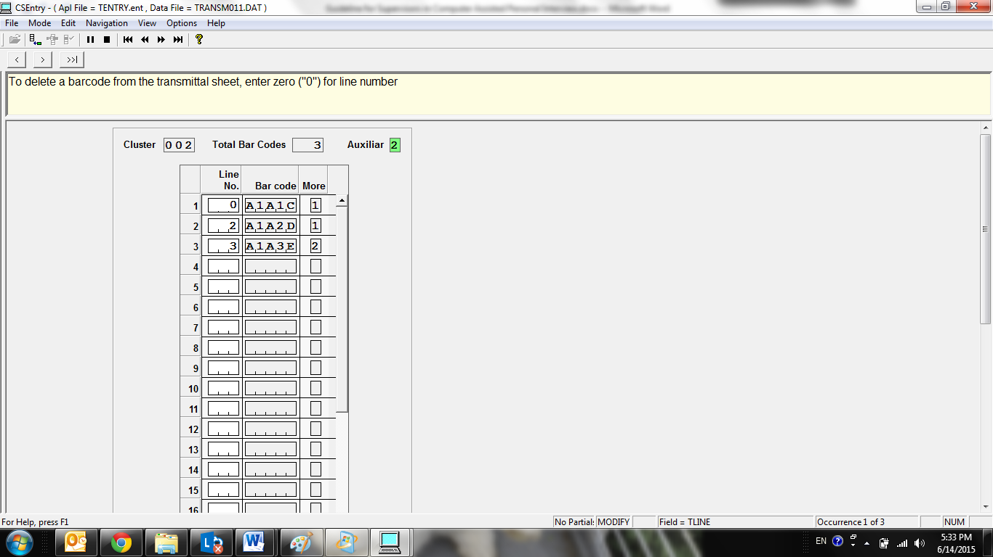

Appendix A. Resolving problems with duplicate cases

In the CC_DHS data collection system, all interviews are identified with identification codes based on cluster number, household number and line number (for individual questionnaires). From time to time, problems can arise when two interviews are created by different interviewers with the same identification codes. This section explains how to identify and resolve problems with duplicate cases.

Duplicate cases typically arise from the following situations:

1. Assignment of households to two different interviewers. The first interviewer visits a household assigned to them and opens the interview, partially saving the cover sheet, to record the fact that the household is not present. Subsequently the supervisor assigns the same household to another interviewer who completes an interview for that household.
2. Poor management of shared households. A household with several eligible members is shared between two interviewers. In error, one interviewer begins and partially saves and interview with a woman whom the other is supposed to interview.
3. Errors made when correcting household numbers.

When there are duplicate cases and the supervisor selects option “4” “List interviewer questionnaire” the following message will appear:

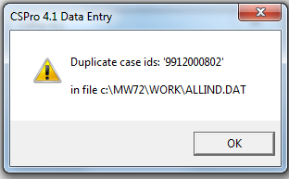

This message indicates that while the program was trying to produce a data file combining all individual questionnaires, it was not able to do so because Cluster “9912”, Household “0008”, line number “02” is duplicated in the data file.

When the supervisor tries to “close” the same cluster (option “7”) the message below explains that Egrin Kachamba has been interviewed by interviewers 21 and 23.

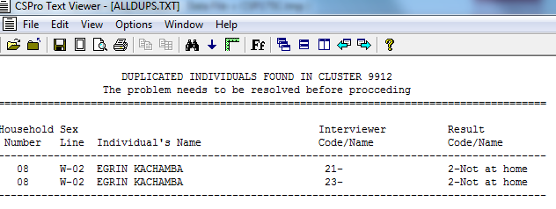

To resolve the problem, carry out the following steps:

* Use the duplicate report to identify the interviewers and the household or individual questionnaire concerned.
* Discuss with the interviewers involved, checking their tablets if necessary
* Decide to either:
  + Delete the case that is not a real interview **OR**
  + Correct the identification codes for one of the interviews
* Remember that all changes have to be made on the tablets of the interviewers
* When the correction has been made, do a transfer of the data from the interviewer machine to supervisor machine to remove the duplicate from your tablet
* “List the interviewer questionnaires” again to verify that the duplicate case has been removed

Refer to section H.2 “Modify/Delete Questionnaire ID codes” of the Guidelines for Computer Assisted Personal Interview” on how to find and repair or delete a case, cluster number, household number, interviewer number or line number of a respondent.

Appendix B. Data Flow in CC_DHS CAPI Operations

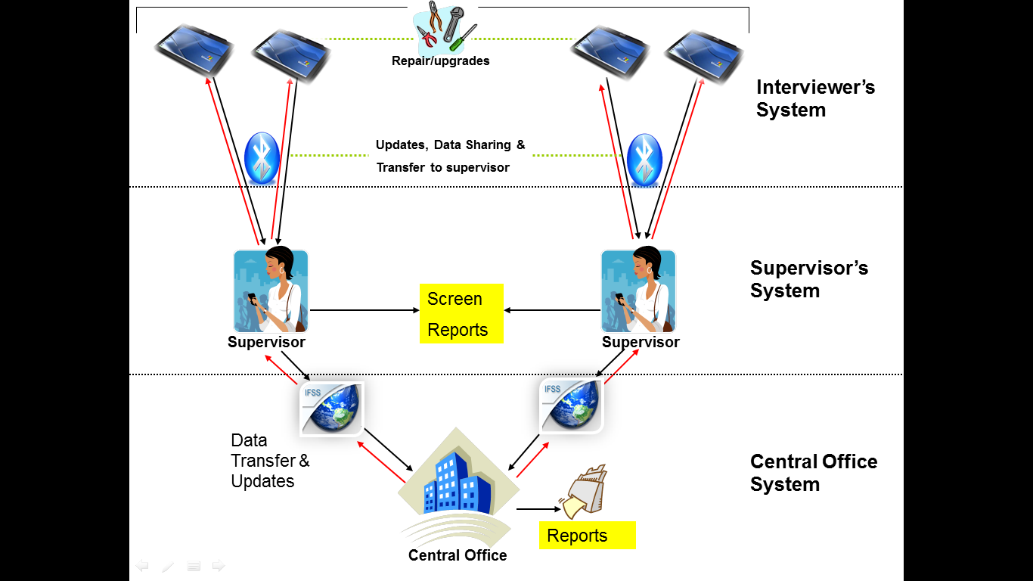

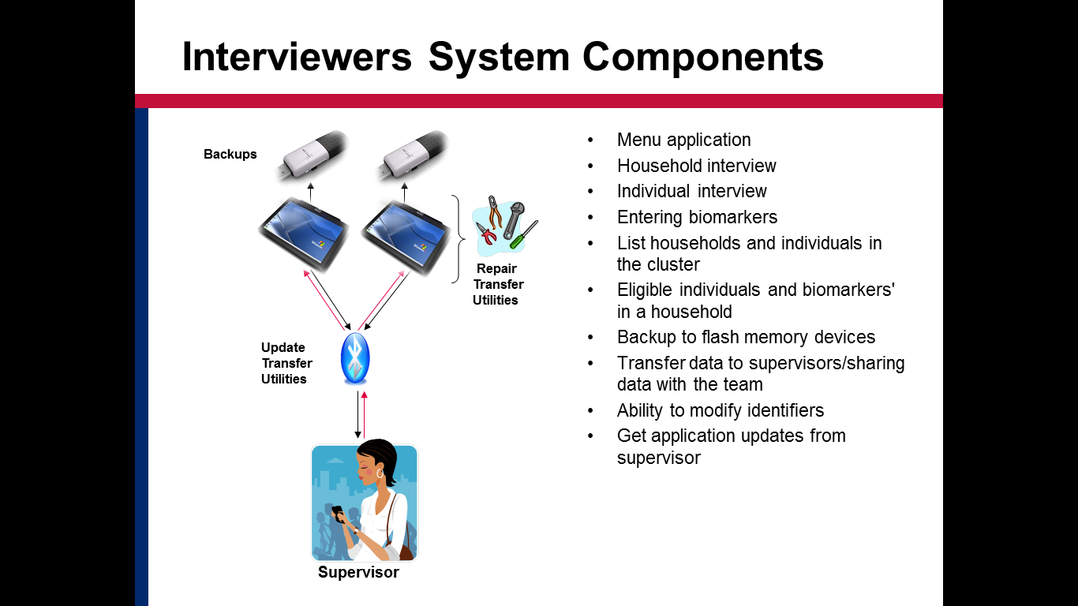

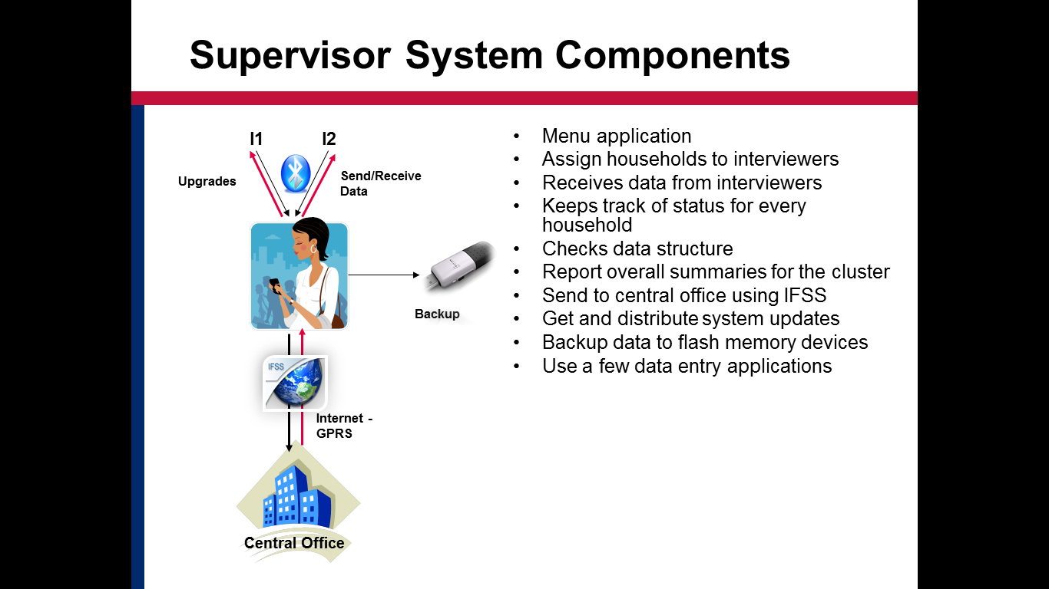

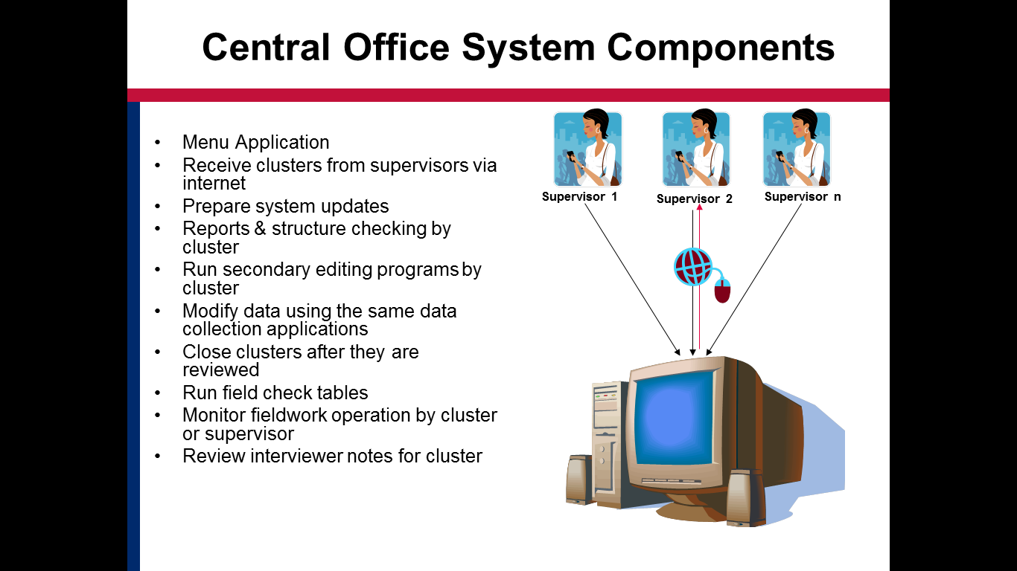

Appendix C. Directories and Files on the tablet

**Interviewer’s tablet**

All folders referenced below are located in the main project folder C:\CC71\.

Data Data from the questionnaires as collected during the interview

H*nnnnnnniii*.* Household questionnaire data

W*nnnnnnniii*.* Women’s questionnaire data

M*nnnnnnniii*.* Men’s questionnaire data

O*nnnnnnniii*.* Other answers data

where *nnnnnnn* is the cluster number

and *iii* is the interviewer number

Entry Questionnaire and Interviewer’s menu programs

DCMENU.ENC – interviewer menu

ENTRYHH.ENC - household

ENTRYWM.ENC – women/men interview

Ref Reference data files used by the programs

Teams Interviewing teams including interviewers and supervisors

Clusters List of EAs

Sample List of selected households in the sample

Utility Utility programs used for Bluetooth transfer, compressing files, upgrading programs, etc.

Work Working files used by the menu and programs

S*nnnnnnn* List of assignments of households in the cluster *nnnnnnn*.

\SD Card\

Backup Backup copy of the data files from Data created after the interviews

Extensions:

.DAT Data file

.DAT.IDX Index to the data file

.DAT.STS Status file recording partially saved cases in the data file

.DAT.NOT Notes files related to the data file

.DAT.LST Listing file (not needed)

.DAT.LOG Log file (not needed)

.DCF.BIN Binary version of dictionary file

.ENC Data entry application compiled file

**Supervisor’s tablet**

The same directories are used on the supervisor’s tablet as on the interviewer’s tablet, but with the following additions:

C:\MW72\

Receive Directory for data received from the interviewers

Temp Temporary directory for working files transferred from interviewers, prior to transferring to the Receive directory

Work Working data files

Reports Report files created by supervisor applications

\SD Card\

Upgrade Directory containing upgrades to transfer to interviewer’s xxx

Appendix D. Error messages

**Supervisor’s Menu**

**001 cluster=nnnnnnn not defined as part of the sample file**

The cluster number entered is not a valid cluster number and cannot be found s part of the sample. Correct the cluster number.

**005 You must select a household**

You are required to select a household to use the requested option. Retry this option and select one of the households listed.

**007 cluster nnnnnnn is not from this district**

The cluster number entered is not from the district selected. Either change the district number or the cluster number.

**008 Sample file SUPERVXXXX.DAT does not exist or is empty**

Neither the sample file for this supervisor (SUPERVnnnn.DAT) nor the general sample file (SUPERVXXXX.DAT) were found or they are empty. Ensure that the sample file exists in the Ref directory.

**011 Household interview incomplete (n)**

This is just a warning message that the household to be reviewed is an incomplete household interview.

**017 There are no files for cluster nnnnnnn interviewer nnn**

Either select the correct cluster or interviewer code and then retry this option. If the cluster and interviewer code are correct, check that the files have been transferred from the interviewer’s tablet.

**018 There are files for cluster nnnnnnn interviewer nnn-xxxx that have not been accepted yet. Change current interviewer and repeat the process**

Data files were transferred from an interviewer to the supervisor, but have not been checked. Change the interviewer number using option 11 to this interviewer and use option 3 to check the files.

**019 Cannot make a copy of files for (nnnnnnniii)**

The copying of the file for cluster nnnnnnn and interviewer iii failed. Try repeating this option. If it still fails, check that the files exist in the Temp directory and check that both the Temp and Receive directories exist.

**020 An individual must be selected**

You are required to select an individual to use the requested option. Retry this option and select one of the individuals listed.

**021 Individual data only transferred. Check will be done when listing or closing the cluster.**

No household data exists from this interviewer, so the only checks that will be done are on individual data, and these will be done when listing or closing the whole cluster.

**022 The previous problems must be fixed before the required task can be executed**

There are duplicate cases or file format problems with the data files. These must be resolved on the interviewer’s tablets and the modified data transferred back to the supervisor before you can continue.

**024 cluster successfully closed**

The supervisor processing of the cluster was successfully completed.

**041 xxxx, in household nnn the first record isn't valid ('xxxx' in line nn)**

The concatenated data file ‘xxxx’ is not a valid file. Household nnn starts with an invalid record identifier. Modify the data for this household in the original interviewer’s tablet, for household, women and men’s files, and then transfer the files back to the supervisor’s computer and try again.

**042 Household file, household nnn duplicated in line nn**

The concatenated data file contains an invalid individual identifier. Modify the original file in the original interviewer’s tablet and then transfer the file again.

**043 Individual file, in household nnn individual nn duplicated in line nn**

A duplicate individual case is found in the concatenated data file for the cluster. Check to see if the individual was started more than once in different tablets. Delete the entry from the tablet of the interviewer who opened the case in their tablet, but did not interview the individual. Use option 4 from the utilities menu (option 11) of the interviewer’s menu.

**055 Individual interview incomplete (n)**

This is just a warning message that the individual questionnaire to be reviewed is an incomplete individual interview.

**060 cluster can't be closed as there are still pending errors**

The closing of this cluster can only take place after all of the errors in the data are resolved. Correct the data on the original interviewer’s tablet and then re-transfer the data files to the supervisor.

**061 The flash memory is not connected to the computer. Connect it and repeat the operation**

The Supervisor SD card for the tablet was not found. Check that the SD is inserted and check that it is the supervisor’s card and not an interviewer’s card.

**067 Can only review individuals for complete households (n)**

Individual interviews can only be reviewed for households with completed household interviews. Check the household number and to ensure that it is the correct household.

**068 Cannot select individuals that haven't been visited**

It is not possible to view the questionnaires of individuals that have not yet been visited. Check the household number and the individual’s name and line number.

**070 Back-up to SD card completed**

The back up was successful

**075 There are still processes pending before the data can be transferred to the central office**

Complete all checks on the EAs data before closing the cluster.

**080 There are no files available yet in the supervisor tablet for cluster xxxx**

Transfer data files from an interviewer prior to attempting to use this option.

**090 The system will shut down so that upgrades take into effect after reentering**

After upgrading the programs on the tablet the CC_DHS system must quit to permit it to restart with the upgraded version. After the program terminates, click **Start**, \**CC_DHSSup** to restart the Supervisor’s menu.

**Structure check messages**

**50040 cluster nnnnnnn has no households assigned for collection (nn)**

Reviewing of questionnaire data can only be done after some interviews have been assigned and the interviews conducted.

**50041 Cannot load control file for cluster nnnnnnn**

The supervisor’s control file for cluster nnnnnnn could not be opened. Check the cluster number and modify as necessary.

**50042 Cannot load household assignments file for cluster nnnnnnn**

The assignments for the selected households for the survey can not be loaded into the computer. Ensure that the sample selection file (SAMPLE.DAT) exists in the Ref directory.

**50050 Household=nnn Persons in household roster (nn) inconsistent with total number of persons (nn)**

The number of persons in the household roster does not agree with the total number of persons recorded on the cover page of the questionnaire. Review the questionnaire on the original interviewer’s tablet and change the data as needed. Then transfer the data back to the supervisor.

**50051 Household=nnn Eligible women in household roster (nn) inconsistent with total eligible women (nn)**

The number of eligible women in the household roster does not agree with the total number of eligible women recorded on the cover page of the questionnaire. Review the questionnaire on the original interviewer’s tablet and change the data as needed. Then transfer the data back to the supervisor.

**50052 Household=nnn Eligible men in household roster (nn) inconsistent with total eligible men (nn)**

The number of eligible men in the household roster does not agree with the total number of eligible men recorded on the cover page of the questionnaire. Review the questionnaire on the original interviewer’s tablet and change the data as needed. Then transfer the data back to the supervisor.

**50054 Household=nnn Weight/height records for xxxx (nn) inconsistent with xxxx eligible for weight and height (nn)**

The number of children/women/men eligible for weight/height/anaemia testing in the household roster does not agree with the total number of children/women/men weighed and measured in the weight/height/anaemia section of the questionnaire. Review the questionnaire on the original interviewer’s tablet and change the data as needed. Then transfer the data back to the supervisor.

**50055 Household=nnn Partially collected, structure not checked**

For partially saved questionnaires, the full structure check is not performed. Complete the interview for this household and then review the structure after the interview is completed.

**50100 Household=nnn Record missing with information for xxxx**

There is on or more record missing from the household data that are expected for a complete interview. If the questionnaire is a partially saved questionnaire, the case should be completed and then re-checked.

**50110 Household=nnn In an incomplete xxxx (result=n), no other records may exist**

There are additional records found for an incomplete interview. If the case is partially saved it should be re-checked. Review and modify the questionnaire on the original interviewer’s tablet and then transfer the data back to the supervisor.

**50150 Number of households found (nn) inconsistent with number of households in the control file (nn) or registered in the table (nn)**

The number of households found in the data is not consistent with the number assigned or the number registered internally. Check and review the households selected and interviewed.

**50151 Number of households found (nn) and registered is correct but there are errors that require resolution**

Correct the outstanding errors and then re-check the data.

**50200 Household=nnn xxxx=nn partially collected, structure not checked**

See 50055.

**50205 Household=nnn Interviewer=nn calendar record missing**

No record was found for the calendar in the women’s questionnaire. Review the questionnaire on the original tablet and correct the problem before re-transferring the data to the supervisor.

**50206 Household=nnn Interviewer=nn birth records (n) inconsistent with total live births (Q208=n)**

The number of births in the history for this woman’s questionnaire does not agree with the number recorded in Q208. Review the questionnaire on the original tablet and correct the problem before re-transferring the data to the supervisor.

**50207 Household=nnn Interviewer=nn Records for maternal care (n) and vaccinations (n) inconsistent with births since January 2003 (Q224=n)**

The number of records in the maternity and vaccinations modules does not agree with the number of births in the birth history since January 2003. Review the questionnaire on the original tablet and correct the problem before re-transferring the data to the supervisor.

**50210 Household=nnn The household has been accepted, but later changes have caused an error**

The household’s questionnaires had previously been accepted as complete, but later changes to the data have led to one or more errors. Review and modify the data on the original tablet to correct the errors and then re-transfer the data.

**50211 Household=nnn Individual questionnaires have been accepted, but later modifications have caused an error**

The individual’s questionnaire had previously been accepted as complete, but later changes to the data have led to one or more errors. Review and modify the data on the original tablet to correct the errors and then re-transfer the data.

**50220 Household=nnn xxxx=nn not visited for individual interview**

The individual has not yet been visited for interview. After interviewing the individual, re-check the data.

**50221 Household=nnn duplicated. Interviewed by nnn and by nnn. Review the households of each interviewer.**

A questionnaire for the household number was already found recorded for a different interviewer. Sometimes one interviewer makes the first visit to a household, but is unable to conduct the interview and a second interviewer then conducts the interview later. In this case, review both questionnaires and delete the case that is for the incomplete interview from the original tablet using option 4 from the utilities menu (option 11) of the interviewer’s menu.

**50225 Household=nnn assigned to interviewer nnn but collected by interviewer nnn.**

**Household assignment updated**

The household questionnaire was originally assigned to a certain interviewer, but a different interviewer conducted the interview. This is just a warning message.

**50300 No GPS data found for cluster nnnnnnn**

For each cluster a global positioning system record is required. Record the GPS coordinates on the paper form and then in the tablet.

**50400 Household=nn not found in the household assignments file. Is this a new split household?**

A new household number was found in the data file. Ensure that this is truly a split household that was previously considered part of a selected household. If so, accept the new household number, but otherwise correct the household number of this case in the original data file on the interviewer’s tablet.

**50401 Household=nnn Invalid household number**

If the household in 50400 is not a split household from a selected household, then the household number is invalid. Correct the household number of this case in the original data file on the interviewer’s tablet.